Assignment No. 4 & 5

Class, Object, Constructor & Constructor chaining

1.Create a class named 'Student' with String variable 'name' and integer variable 'roll_no'. Assign

the value of roll_no as '2' and that of name as "John" by creating an object of the class Student.



2. Assign and print the roll number, phone number and address of two students having names

"Sam" and "John" respectively by creating two objects of class 'Student'.

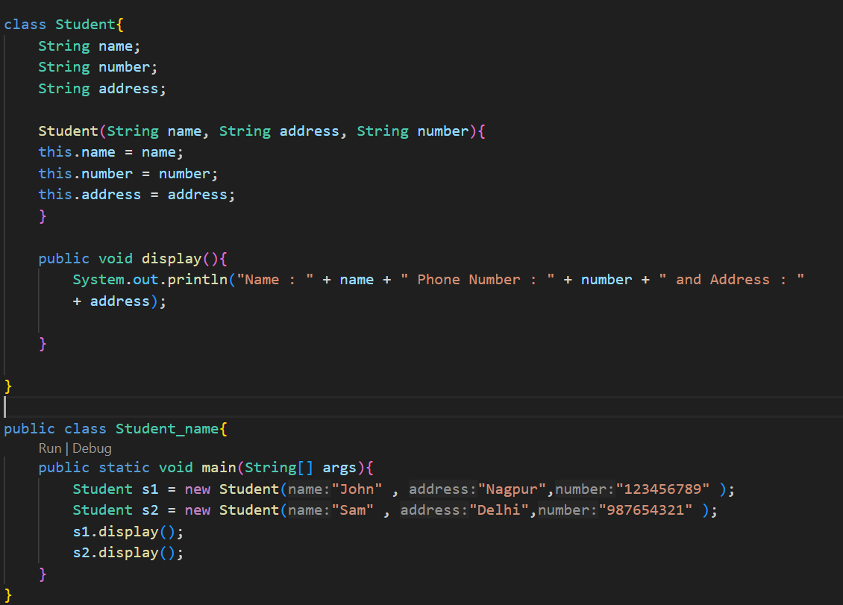



3. Write a program to print the area and perimeter of a triangle having sides of 3, 4 and 5 units by

creating a class named 'Triangle' without any parameter in its constructor.

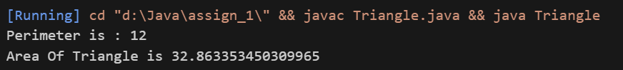

4. Write a program to print the area and perimeter of a triangle having sides of 3, 4 and 5 units by

creating a class named 'Triangle' with the constructor having the three sides as its parameters.

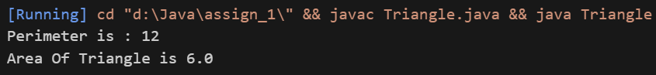

5. Write a program to print the area of two rectangles having sides (4,5) and (5,8) respectively by

creating a class named 'Rectangle' with a method named 'Area' which returns the area and length

and breadth passed as parameters to its constructor.

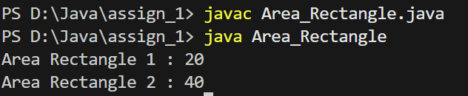

6. Write a program to print the area of a rectangle by creating a class named 'Area' having two

methods. First method named as 'setDim' takes length and breadth of the rectangle as parameters

and the second method named as 'getArea' returns the area of the rectangle. Length and breadth of

the rectangle are entered through the keyboard.

7. Write a program to print the area of a rectangle by creating a class named 'Area' taking the

values of its length and breadth as parameters of its constructor and having a method named

'returnArea' which returns the area of the rectangle. Length and breadth of rectangle are entered

through the keyboard.

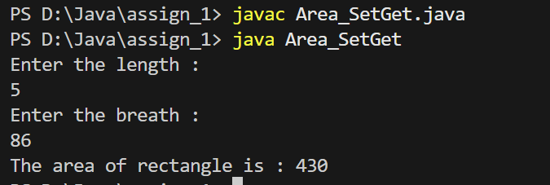

8. Print the average of three numbers entered by the user by creating a class named 'Average'

having a method to calculate and print the average.

9. Print the sum, difference and product of two complex numbers by creating a class named

'Complex' with separate methods for each operation whose real and imaginary parts are entered by

the user.

10. Write a program that would print the information (name, year of joining, salary, address) of

three employees by creating a class named 'Employee'. The output should be as follows:

Name Year of joining Address

Robert 1994 64C- WallsStreat

Sam 2000 68D- WallsStreat

John 1999 26B- WallsStreat

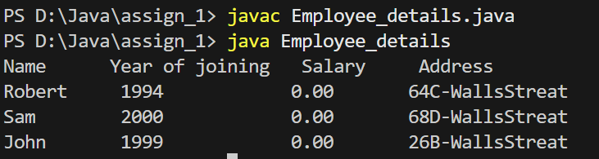

Question 4

Write a Java class Author with following features:

* ● Instance variables :
  + firstName for the author’s first name of type String.
  + lastName for the author’s last name of type String.
* ● Constructor:
  + public Author (String firstName, String lastName): A constructor
  + with parameters, it creates the Author object by setting the two fields to
  + the passed values.
* ● Instance methods:
  + public void setFirstName (String firstName): Used to set the first name of the author.
  + public void setLastName (String lastName): Used to set the last name of the author.
  + public double getFirstName(): This method returns the first name of the author.
  + public double getLastName(): This method returns the last name of the author.
  + public String toString(): This method printed out author’s name to thescreen



1.Write a program by creating an 'Employee' class having the following methods and print the

final salary.

1 - 'getInfo()' which takes the salary, number of hours of work per day of employee as parameter

2 - 'AddSal()' which adds $10 to the salary of the employee if it is less than $500.

3 - 'AddWork()' which adds $5 to the salary of an employee if the number of hours of work per

day is more than 6 hours.

====================================================================================

1. Constructor Chaining within the Same Class

Create a class Car with multiple constructors that initialize different attributes using

constructor chaining.

Problem Statement:

* Create a class Car with attributes brand, model, and price.
* Implement constructor chaining within the same class:
* One constructor should only take the brand.
* Another constructor should take brand and model.
* The final constructor should take brand, model, and price.
* Use the this() keyword to call other constructors.
* Display car details in each constructor.

✅ Task: Create objects using different constructors and observe constructor chaining in

action.

2. Constructor Chaining Using super Keyword (Parent-Child Relationship)

Create a class hierarchy where the child class calls the parent class constructor using

super(). Problem Statement:

* Create a Person class with attributes name and age.
* Create a Student class that extends Person and has an additional attribute course.
* Use constructor chaining:
* Person class should have a constructor initializing name and age.
* Student class should use super(name, age) to call the Person constructor and then initialize course.
* Display details in both constructors.



Demonstrate constructor chaining in a multi-level inheritance scenario.

Problem Statement:

* ● Create a Vehicle class with an attribute type.
* ● Create a subclass FourWheeler with an additional attribute brand.
* ● Create another subclass Car with attributes model and price.
* ● Use multi-level constructor chaining:
  + ○ Vehicle initializes type.
  + ○ FourWheeler calls super(type) and initializes brand.
  + ○ Car calls super(type, brand), initializes model, and price.
* ● Display details at each level.

✅ Task: Create a Car object and verify that constructors are executed from parent → child

→ grandchild.

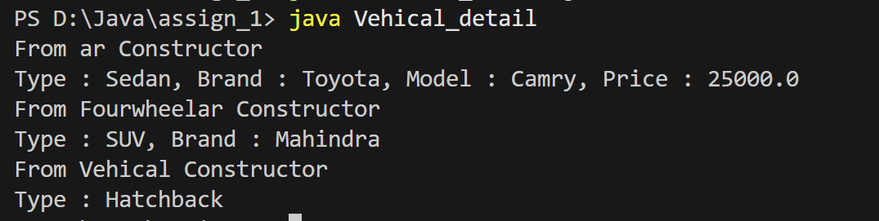

4. Constructor Chaining in an E-Commerce Scenario

Create an Order class where different constructors initialize order details using

constructor chaining.

Problem Statement:

* ● Create an Order class with attributes orderId, customerName, and totalAmount.
* ● Implement constructor chaining within the same class:
  + ○ One constructor initializes only orderId.
  + ○ Another constructor initializes orderId and customerName by calling the first constructor.
  + ○ The final constructor initializes all three attributes (orderId, customerName, totalAmount) by calling the second constructor.
* ● Display order details.

✅ Task: Create Order objects using different constructors and verify how chaining works.

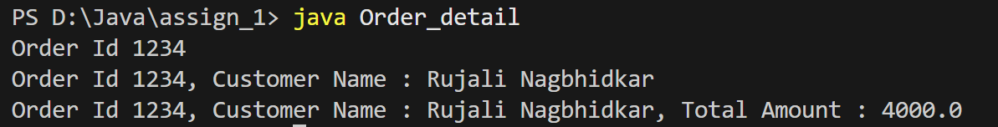

5. Constructor Chaining in a Banking System

Create a BankAccount class where constructor chaining initializes different account

types.

Problem Statement:

* ● Create a BankAccount class with attributes accountNumber, holderName, and balance.
* ● Implement constructor chaining:
  + ○ One constructor initializes only accountNumber.
  + ○ Another constructor initializes accountNumber and holderName, calling the first constructor.
  + ○ The final constructor initializes all three attributes by calling the second
* constructor.
* ● Implement a method to display account details. ✅ Task: Create BankAccount objects using different constructors and verify the constructor
* call sequence.

